A - Verificación de protocolo de autenticación del beneficiario e identificación del vehículo

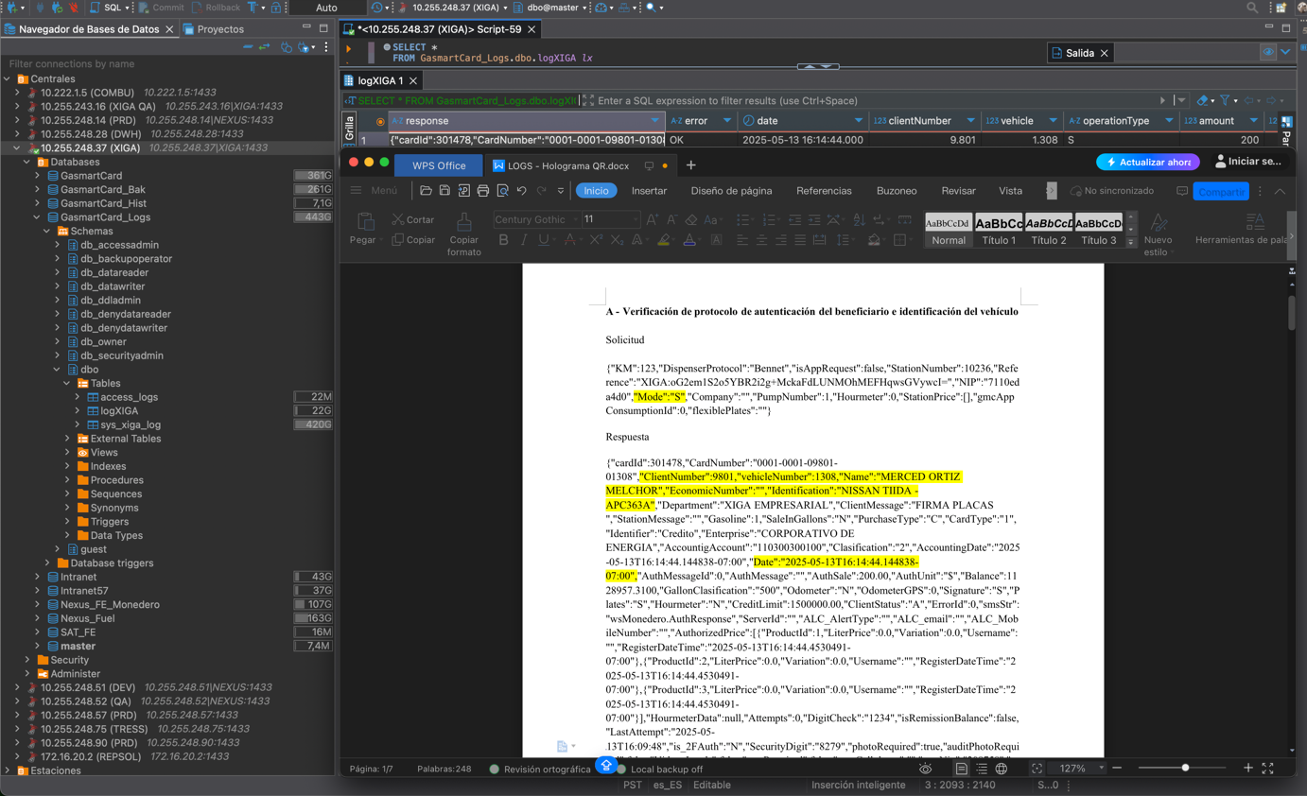
Saldo autorizado
Código y Mensaje
Placas
Identificador del Vehículo
Nombre del Usuario
NIP Encriptado
Referencia Encriptada

Solicitud

{"KM":123,"DispenserProtocol":"Bennet","isAppRequest":false,"StationNumber":10236,"Reference":"XIGA:oG2em1S2o5YBR2i2g+MckaFdLUNMOhMEFHqwsGVywcI=","NIP":"7110eda4d0","Mode":"S","Company":"","PumpNumber":1,"Hourmeter":0,"StationPrice":[],"gmcAppConsumptionId":0,"flexiblePlates":""}
Respuesta
{"cardId":301478,"CardNumber":"0001-0001-09801-01308","ClientNumber":9801,"vehicleNumber":1308,"Name":"MERCED ORTIZ MELCHOR","EconomicNumber":"","Identification":"NISSAN TIIDA -APC363A","Department":"XIGA EMPRESARIAL","ClientMessage":"FIRMA PLACAS ","StationMessage":"","Gasoline":1,"SaleInGallons":"N","PurchaseType":"C","CardType":"1","Identifier":"Credito","Enterprise":"CORPORATIVO DE ENERGIA","AccountigAccount":"110300300100","Clasification":"2","AccountingDate":"2025-05-13T16:14:44.144838-07:00","Date":"2025-05-13T16:14:44.144838-07:00","AuthMessageId":0,"AuthMessage":"","AuthSale":200.00,"AuthUnit":"$","Balance":1128957.3100,"GallonClasification":"500","Odometer":"N","OdometerGPS":0,"Signature":"S","Plates":"S","Hourmeter":"N","CreditLimit":1500000.00,"ClientStatus":"A","ErrorId":0,"smsStr":"wsMonedero.AuthResponse","ServerId":"","ALC_AlertType":"","ALC_email":"","ALC_MobileNumber":"","AuthorizedPrice":[{"ProductId":1,"LiterPrice":0.0,"Variation":0.0,"Username":"","RegisterDateTime":"2025-05-13T16:14:44.4530491-07:00"},{"ProductId":2,"LiterPrice":0.0,"Variation":0.0,"Username":"","RegisterDateTime":"2025-05-13T16:14:44.4530491-07:00"},{"ProductId":3,"LiterPrice":0.0,"Variation":0.0,"Username":"","RegisterDateTime":"2025-05-13T16:14:44.4530491-07:00"}],"HourmeterData":null,"Attempts":0,"DigitCheck":"1234","isRemissionBalance":false,"LastAttempt":"2025-05-13T16:09:48","is_2FAuth":"N","SecurityDigit":"8279","photoRequired":true,"auditPhotoRequired":false,"Video_Loads":false,"smsRequired":false,"userCellphone":"","smsNip":"208758","emailTicketRequired":false,"adminEmail":"JROCHA@PACIFICOARRENDAMIENTOS.COM","printTicketBalance":false,"AuthorizedPumps":[],"CardPhotos":[{"photo_type":1,"description":"Placas","photo":null}],"platesNumber":"APC363A","clientFullname":"CORPORATIVO DE ENERGIA, SERVICIOS Y DESARROLLO DE NEGOCIOS","clientRFC":"CGA1310281K8","isEZTrackEnabled":false,"lastReportedOdometer":9999,"validateOdometerLecture":false,"odometerLectureLimit":500,"vehicleCode":"0","proodosLocalBalance":0.00,"isSpecialClientFuelDiscount":false}

